Week 3 Day1

Class Assignment

Adding Radio button

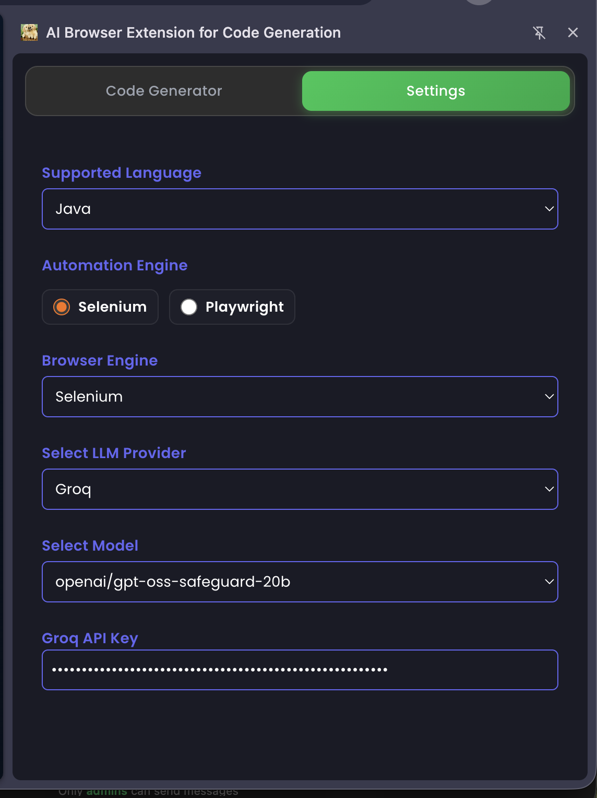

Home Work1

Adding Typescript to Playwright and inspecting

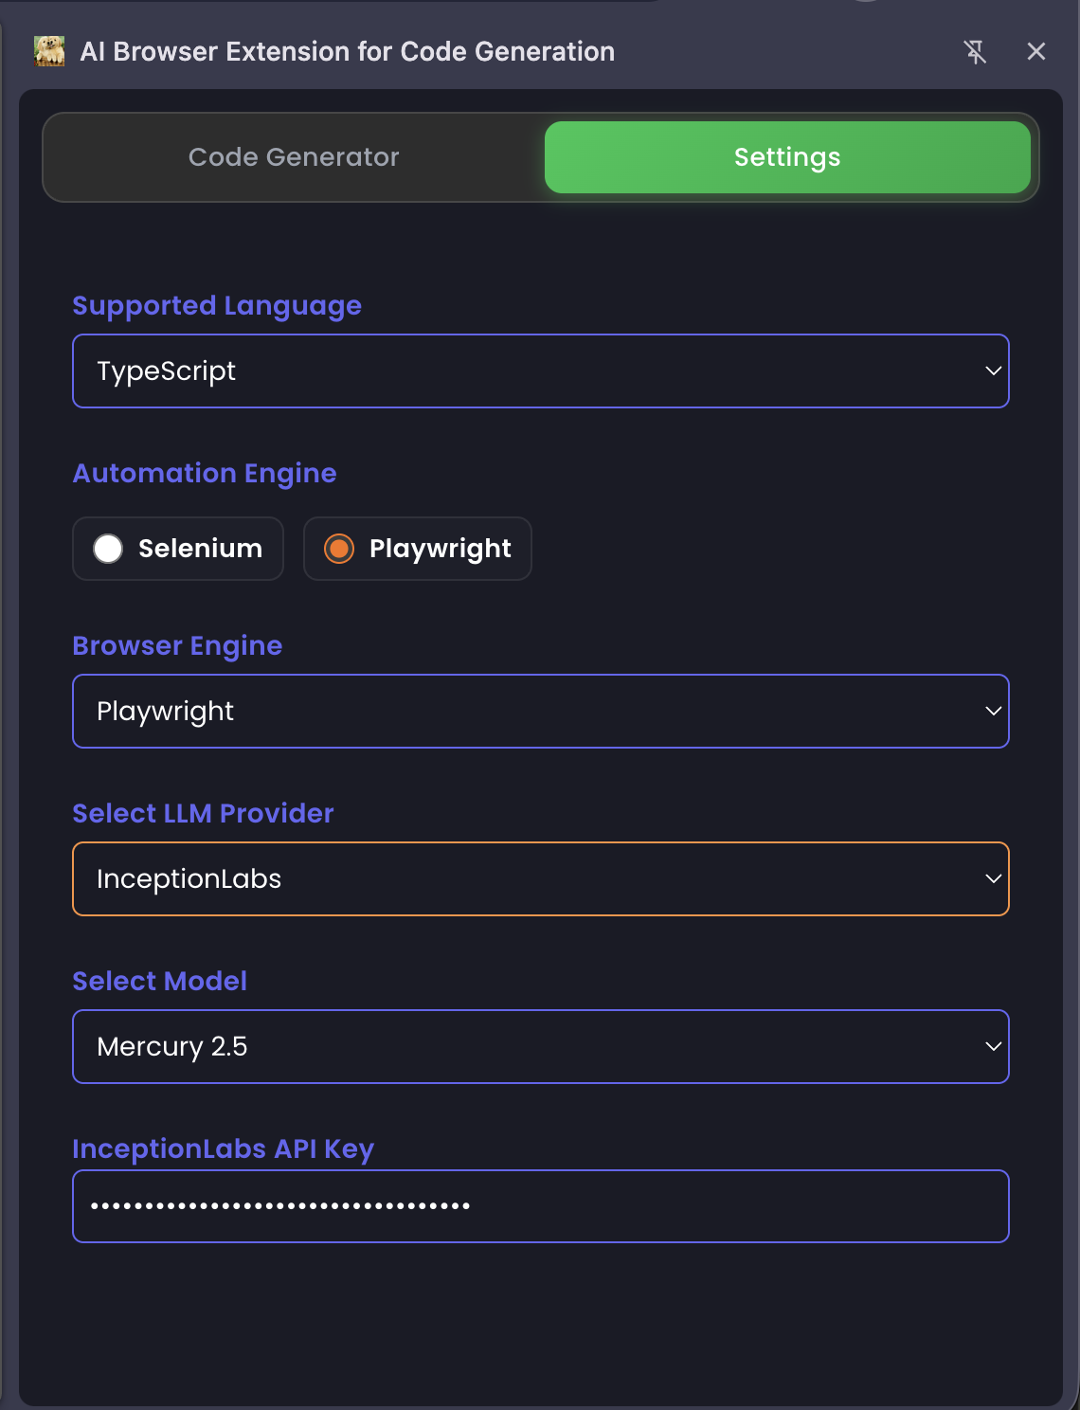

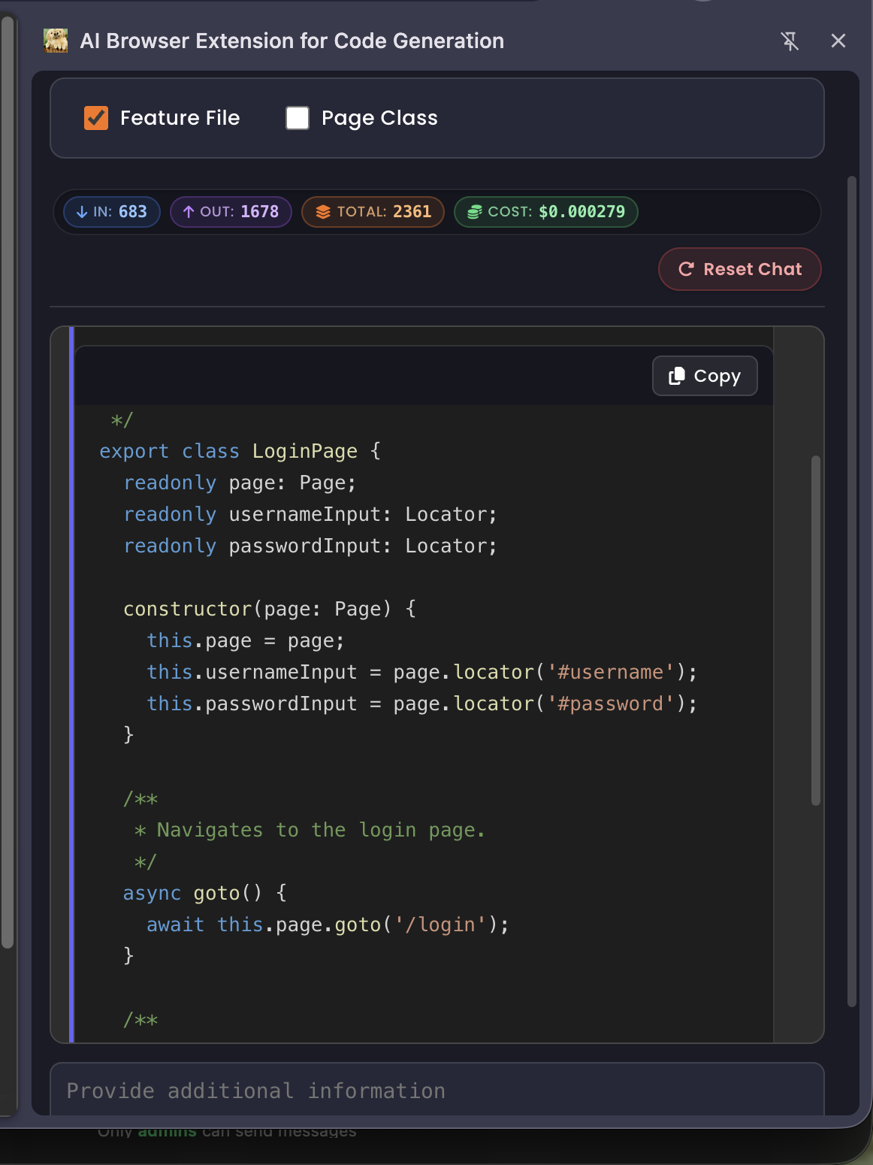

HomeWork2:

Including a third model
